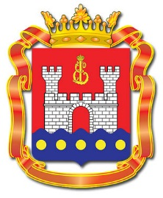 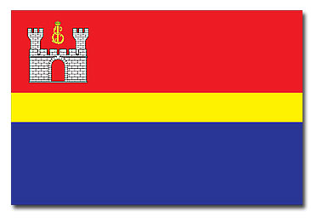

**PASSPORT**

**of the Kaliningrad Region**

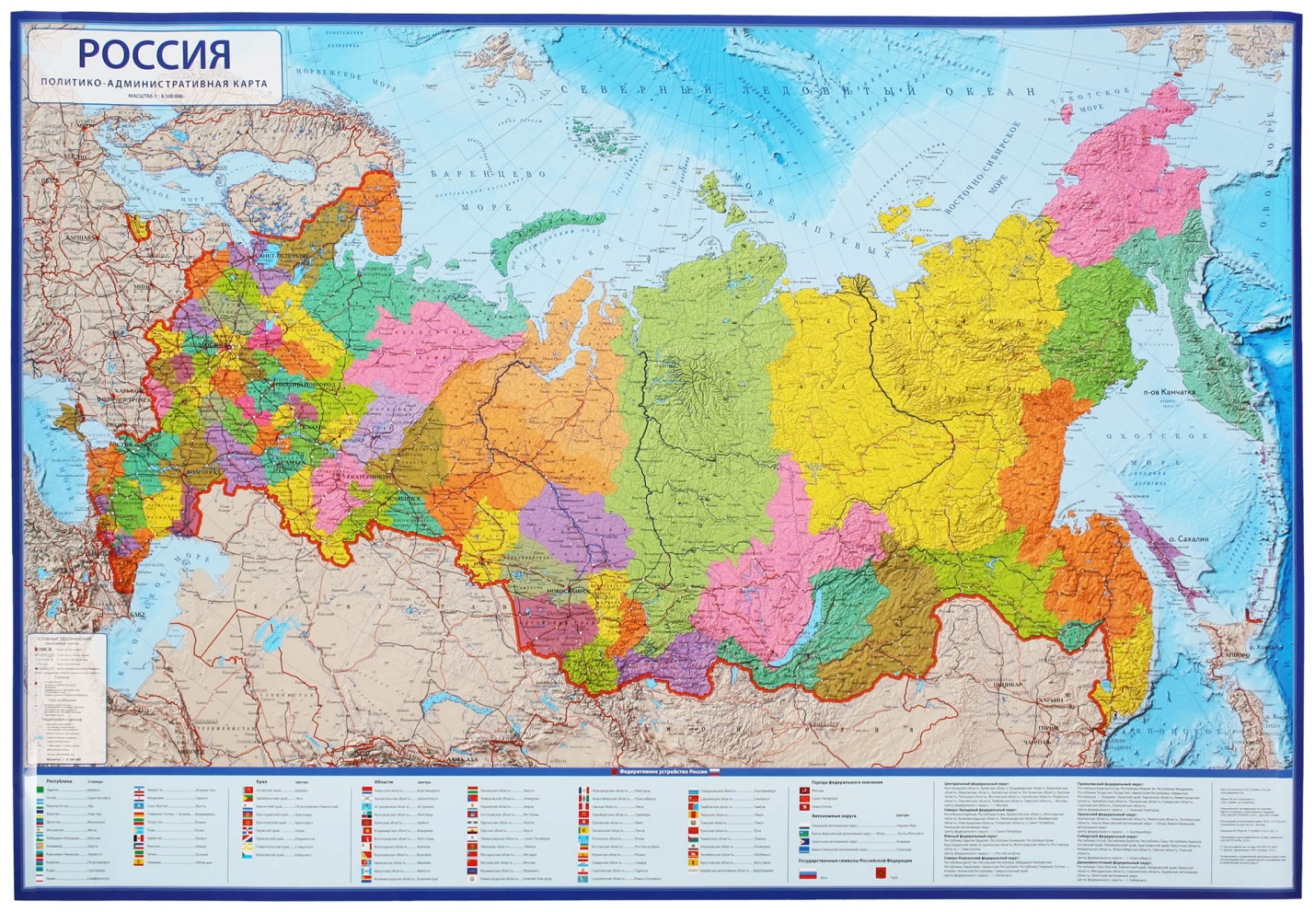

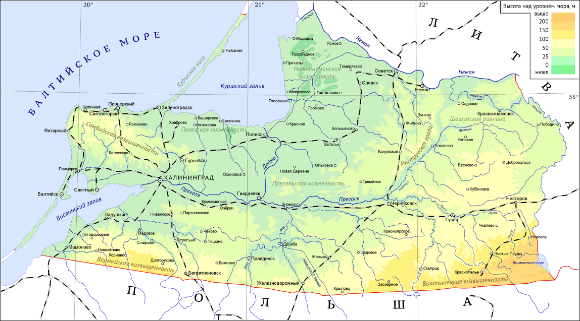

Date of Foundation

The Kaliningrad Region was founded as a result of the Potsdam Agreement, 1945. In accordance with the latter the Northern part of East Prussia – 1/3 – was awarded to the USSR and transformed into the Konigsberg Special Military District with Konigsberg as a major city. The Konigsberg Region was established by the Decree of the USSR Supreme Soviet Presidium on April 7, 1946, and became part of the RSFSR on July 4, 1946. Later the region changed its name after Soviet official M. Kalinin.

Geographical Location

**The Kaliningrad Region** is situated on the southeastern coast of the Baltic Sea. It is fully separated from the Russian mainland by borders with foreign countries. In the south it borders with Poland, in the north and east - with Lithuania. The west coast is washed by the Baltic Sea including the Curonian and Kaliningrad (Vistula) Lagoons with an area of Russian parts as 1.3 and 0.5 thousand square kilometres respectively.

The region belongs to the zone of mixed forests that make up 15% of the territory. Kaliningrad flora and fauna are rich comprising 1,300 plant species, 400 species of vertebrates, 160 species of birds, and 100 species of fish. There are extracted amber, petroleum, salt, and peat in the region. 90% of world opencast amber mining is carried out here.

Federal District

It is a part of Northwestern Federal District.

Area

**The total area** of the region including the lagoons is 15.1 thousand km2, the land area is 13.3 thousand km2. Maximum east-west extent is 205 km, north-south width is 108 km. Most of the territory is lowland. In the South-East, the Baltic Upland (either Vishtynets or Vištytis Upland) reaches up to 240 m.

Population

As of December 31, 2024, the Kaliningrad Region **resident population** made up 1,033,128 that is 1,581 more than the figure of 2023. In 2024, migration growth amounted to 6,227 fully compensating for natural loss (822).

Major Cities

**Administrative centre:** Kaliningrad (population as of December 31, 2024, 489,584 people). Other major cities are Sovetsk, Chernyakhovsk, Baltiysk, Gusev. There have been 22 municipalities since 2019.

**Public authorities** are divided into executive (the Government of the Kaliningrad Region headed by Governor A. Besprozvannykh), legislative (the Kaliningrad Legislative Assembly (formerly the Kaliningrad Regional Duma) headed by A. Kropotkin), and judicial (the Regional Court headed by E. Bykov).

Current **Official symbols** (coat of arms and flag) were approved by Law 16 of the Kaliningrad Region of June 9, 2006.

Ethnic Diversity

147 ethnic groups reside in the Kaliningrad Region. Among the largest of them there are Russians (86.4%), Ukranians (3.7%), Belarussians (3.6%), Lithuanians (1.1%), Armenians (1%), Germans (0.8%), Tatars (0.5%), Azerbaijanis (0.4%), Poles (0.3%), Uzbeks (0.3%), Kazakhs (0.08%).

**Economic and Social Development of the Kaliningrad Region**

Political and socio-economic situation is stable. The Kaliningrad Region develops in accordance with a medium- and long-term strategy that stipulates the following priorities:

- industrial and automotive manufacturing;

- ship building;

- amber processing;

- agriculture and fish industry;

- tourism industry;

- innovation and hi-tech industries.

Since January 1, 2018, up to December 31, 2045, a new simplified tax regime model of the Special Economic Zone (SEZ) is in effect. As of December 31, 2024 the number of active investment projects in the SEZ was 322. The total amount of declared investments in the first three years of investment project implementation from the date of joining the SEZ was 229.984 billion roubles and the total number of staff (when reaching the planned production capacity) is going to reach 61,068 people.

35 new investment projects were included in the SEZ from January 1, 2024 to December 28, 2024. Their declared investments in the first three years of implementation are said to be 33.256 billion roubles and planned staffing (when reaching the planned production capacity) is going to increase to 5,135 including 841 current positions.

**Industrial Production**

Industrial production of the region is showing positive trends. According to the data of Federal State Statistics Service, in 2024 the index of industrial production compared to 2023 amounted to 103.5%. In the Russian Federation as a whole the index was 104.6%.

Well-grounded expectations are focused on new Rosatom-led Li-ion battery plant. At the same time, Encore solar battery plant became the first in Chernyakhovsk Industrial Park. The park also houses Atlantis company that grows and produces premium French fries and other frozen goods.

Main industrial companies of the region are the following:

1. Avtotor Plant produces Chinese car brands Kaiyi Auto, BAIC, SWM, JMC, Dongfeng as well as local China-designed Amberauto.

2. Yantar Shipyard repairs and builds modern warships and other high-performance vessels.

3. Lukoil Kaliningradmorneft produces oil and gas and develops the fields.

4. Baltinox produces stainless steel tubes.

5. Baltkran supplies lifting equipment and complex crane systems for container terminals, ports, nuclear plants, and thermal power stations.

**Mineral Extraction**

The Kaliningrad Region mineral base includes fields of oil, amber, peat, sand and gravel, clay, fresh and mineral water, therapeutic mud, potassium salt, rock salt, brown coal.

Comparative month-to-month analysis of mineral extraction rate of 2023 and 2024 demonstrates unstable dynamics. So, the year 2024 indicates 2-25 % lag in extraction volumes compared to the figures of 2023.

**Construction**

The construction industry has been demonstrating sustainable positive trends. The amount of construction work for 2024 reached 124.7 billion rubles that corresponds to 115.8% compared to the same period in 2023 when contrasting the prices.

**Agriculture**

In 2024, the Kaliningrad region became the second in Russia in terms of grain and leguminous crops harvesting (57.2 centners per hectare) due to the improvement of cultivation technologies and timely fertilizing. Thus, there was 9% increase compared to the figures of 2023.

In 2024, poultry meat production in farms of all categories increased by 9%, pork - by 12%, beef - by 14%. The region is almost 90 per cent supplied with dairy products and 97 per cent with eggs.

Dolgov Group Agricultural Holding is the largest agricultural enterprise of the Kaliningrad Region with a completely self-contained closed-cycle structure from the field to the counter. It includes plant for deep processing of rapeseed, soybean, and sunflower seed.

**Foreign Economic Activity**

The Kaliningrad Region is an import-oriented Russian territory. In 2024, the export values to non-CIS countries reached 69.8% of the total export value. Export indicators of the region in 2024 reached the value of USD 1,820,639.1. The three leading partners of the region are China, India and Belarus.

Food products and agricultural raw materials prevail in the export structure. The most demanded goods are rape seeds, flax seeds, soya meal, soya beans, polyesters, coal, tinned fish.

Goods are imported mainly from non-CIS countries which make 95.3% of the total value of imports. The main import items are: equipment, ferrous metal products, electrical machinery

**International Cooperation**

In the region, there are the Republic of Belarus Embassy Office and three EU consular offices: Lithuania (2) and Poland. The number of consular offices was reduced in response to Russian diplomats’ expulsion. There are also four honorary consuls of the following countries: Croatia, Greece, Kazakhstan.

Long-Term Cooperation Russian-Belorussian Council goes on working as a tool of regional partnership.

Nevertheless, the region has been frequently used as a venue for international forums. In 2024, Kaliningrad hosted events dedicated to I. Kant 300th anniversary. The World Youth Festival 2024 regional stage took place in March to unite participant from 40 states including the EU ones, Australia, Africa, and South America. All-Russian Forum SHUM held in Aug-Sep 2024 also attracted international delegates from 86 countries.

**Science**

Science is represented by Shirshov Institute of Oceanology of the Russian Academy of Sciences (RAS), Kaliningrad Agriculture Research Institute of the RAS, the Biological Station of the RAS Zoological Institute, state universities: Immanuel Kant Baltic Federal University and Kaliningrad Technical University that includes Baltic Fishing Fleet State Academy.

**Educational Structure**

Kaliningrad educational structure includes:

- 161 municipal institutions of general education;

- 268 institutions of preschool education;

- 17 institutions of secondary vocational education;

- 12 institutions of higher education (including branches). The major higher education institution is Immanuel Kant Baltic Federal University.

**Institutions of Culture and Art**

The region has 531 institutions of culture and art, four of which are federal. There are 1251 architectural, historical and cultural monuments including the Curonian Spit National Park from UNESCO’s Cultural Heritage List.

Besides 6 concert facilities, 252 libraries and a zoo, there are four theatres, 37 children art schools, 14 museums with such major institutions as the Museum of the World Ocean and its vessels moored at the museum quay, the Regional Museum of History and Art with its four branches, the Amber Museum, Kaliningrad Museum of Fine Arts.

The Kaliningrad Region hosts music and theatre festivals “Amber Necklace”, “Musical Spring”, “Kaliningrad City Jazz”, “Baltic Debuts”, “Baltic Seasons” as well as competitions “Amber Nightingale” (chamber vocal), “Mikael Tariverdiev International Organ Contest” (music), “Serenading KiViN” (humour).

The Kaliningrad Region registered four news agencies, 18 radio stations, 5 TV channels, 33 online media, two electronic periodicals, 44 newspapers, 28 magazines.

**Transport Infrastructure**

Transport infrastructure of the region includes 963 km of railways, more than 4800 km of roads, and 570 km of inland waterways. There are 21 Russian border crossing checkpoints. Border control is conducted at 8 checkpoints (3 road border checkpoints, a railway border checkpoint, 3 sea border checkpoints, Khrabrovo Airport border checkpoint).

What makes Kaliningrad railways unique is tracks of two types that is a standard gauge of 1435 mm from Chernyakhovsk and Kaliningrad (105 km) and 858-km line of 1520 mm to Russian and Polish border checkpoints Mamonovo – Braniewo and Zheleznodorozhy – Skandawa.

Public road network is one of the most well-developed in Russia. Kaliningrad road density is 352 km per 1000 km2, which is higher than the average Russian level of 67 km per 1000 km2.

The port of Kaliningrad includes sea commercial, sea fishing, and river ports. The Sea Port is the only Russian ice-free Baltic port. Sea border checkpoints are in Kaliningrad, Baltiysk, and Svetly.

In 2024, up to 28 vessels were operating on the line between Kaliningrad and ports of the Leningrad Region, the four of which are Ust-Luga – Baltiysk railway ferries: the Ambal, Baltiysk, Marshal Rokossovsky, and General Chernyakhovsky. The latter two vessels became Russia’s first ones to make unmanned commercial voyages.

The largest of the ports of Kaliningrad, the Kaliningrad Sea Commercial Port (KSСP), handled 1 million 750 thousand tons of cargo in 2024, which is 15% more than the year before (1.487 million tons). Currently, KSCP mainly receives ships that connect the Kaliningrad region with the main territory of Russia.

Nowadays sea transportation between the Kaliningrad Region and “mainland” Russia is crucial for the semi-exclave economy. Most part of local industry is tied to the shipping because of the need for components. Being the key enterprise for the region, Avtotor had to switch over to ferries since September 2023 in order to supply their cars to other Russian regions as a result of sanctions and Lithuanian railway quotas. At the same time, the demand for rolling ferry fleet enlarging is still acute. In 2024-2025, the rolling ferries are to be redirected to the much awaited Port of Pionersky.

Khrabrovo Airport Capacity is up to 5 mln passengers a year. On November 2021, there was introduced the Open Skies Regime of the seventh freedom of air. The passenger traffic of Khrabrovo Airport on domestic flights reached 4.4 million people in 2024, which is 12.5% ​​more than in 2023.

**Tourist Potential**

Tourist potential builds upon two federal seaside resorts Zelenogradsk and Svetlogorsk, the Curonian Spit National Park, and seven nature reserves.

**The MFA of Russia Representative Office in Kaliningrad** is located at: 17 Kirova st., 236035, Kaliningrad, Russia. Tel.: +7(4012) 21-37-12, fax: +7(4012) 21-06-26, e-mail: [kaliningrad@mid.ru](mailto:kaliningrad@mid.ru).